CST 2550 COURSEWORK 1 REPORT

Jettlance Rivera (M00863406)

Contents

Introduction 1

Person 2

Member 3

Book 4

Librarian 5

# Introduction

**Student Number: M00863406**

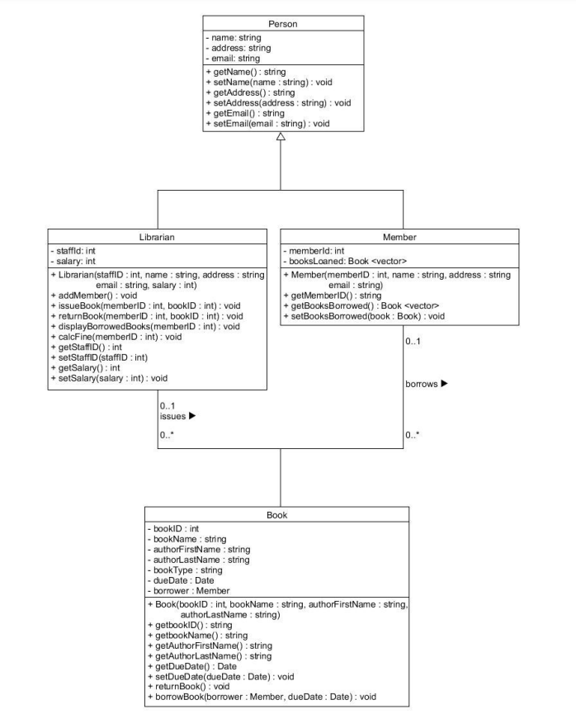For this report, I will be giving an explanation on how I have used the provided UML diagram provided to design the software and implement the person, librarian, member and book classes into C++.

The provided UML diagram has the sole purpose of making up a library system which has the features of allowing a librarian to add a member to the library system by specifically using their details such as their name, address and email address. The librarian should also be able to issue a book to a member of the library system, return a book borrowed, display all books borrowed and to calculate the fine for a member who has handed in their book past the due date.

# Person

A class named ‘person’ is declared which encloses information about a member of the library. With the help of private attributes such as name (std::string name), address (std:: string address) and email (std::string email), it can store the person’s details. Shortly after creating the private attributes, a constructor is made to ensure that a new member of the library system is added only if they have given the specified values (name, address, email). Getter functions are then made to retrieve the values of the private attributes and finally finished with the setter functions which were made to help update the information stored inside the class by providing new attributes.

# Member

The class ‘member’ is declared and shares similarities with the ‘person’ class, inheriting its attributes. For example, both represent personal information such as name, address and email. Similarly, to class ‘person’, private attributes such as name, address and email are made with the exception of adding on a number that is unique to all library members (memberID) as well as the booksLoaned which represents books that have been loaned to be stored in a vector. After the private attributes have been created, a constructor is made to ensure that it is a member only if they have the specified values of name, address, email and memberID. Getter functions are then created to return the ‘memberID’ of the member and to also return a copy of the vector ‘booksLoaned’, representing the books borrowed by the member according to their specific ID. Finally, a setter function is created to show that a book has been taken and added to booksLoaned vector, indicating that the member has borrowed the book.

# Book

The class ‘book’ is declared with private data members which represent a book such as bookID (unique number for book), bookName, authorFirstName, authorLastName, bookType, the due dates and the borrowerName. This constructor takes four parameters id, name, firstName and lastName and initializes the member variables (bookID, bookName, authorFirstName and authorLastName. Getter functions are then created to retrieve the previously stated variables. As for the setter functions, its main role is to set the due date for the book.

* Void borrowBook: Function that is used when a book is borrowed. Inside this function, the setBorrower and setDueDate functions are called to update the borrower’s information and set the due date. Prints a message on who borrowed the book and the due date.
* Void returnBook: Function that is used when a book is returned. It checks if the book is borrowed by checking if borrowerName is not empty. If book is borrowed, it prints a message on who returned the book. After setBorrower and setDueDate are called to reset the due date and borrower information. Otherwise, will print another message.

# Librarian

The class ‘librarian’ is declared. Here, the class has private data members to store information about the librarian such as staff ID, name, address, email, the salary and a vector to store the IDs of books borrowed by library members. With the constructor, it initializes the librarian’s information.

Void addMember: function to add a library member, printing the message ‘Member added’ to the console.

Void issueBook:It takes two parameters, memberID and bookID, Adds the given bookID to the list of books borrowed by a library member with the specified memberID and prints ‘book issued to member (memberID) to the console.

Void returnBook: It takes two parameters, memberID and bookID, searches for bookID in the list of borrowed books. If found, the book from the list is removed and prints ‘book returned by member (memberID) . If not found, it prints ‘book not found in the list of borrowed books.

Void displayBorrowedBooks: Takes one parameter memberID and prints the list of borrowed books for the member.

Void calcFine: function to calculate fines for a library member (prints fine calculated for member)

std:string get CSVFileNameFromUser(): Asks the user to enter a CSV file name and returns the entered name as a string

As for the getter and setter functions, it returns the staff ID of the librarian or sets the ID to new a value. Additionally, it returns the salary of the librarian or sets the salary to a new value